Ensure you’ve read the textbook and PPT slides before proceeding. Also, you may want to

review previous material on creating VLANs and ACCESS/TRUNK modes.   
  
Note: This lab refers to PC as the 4th byte of the IP address; ex: PC**3** is 172.1.30.**3**.

**Part 1: Initial Topology**

**Step 1: Create and Configure the initial topology**

Follow the ROUTER ON A STICK demonstration topology in the slides and video.

Your working topology should look like:

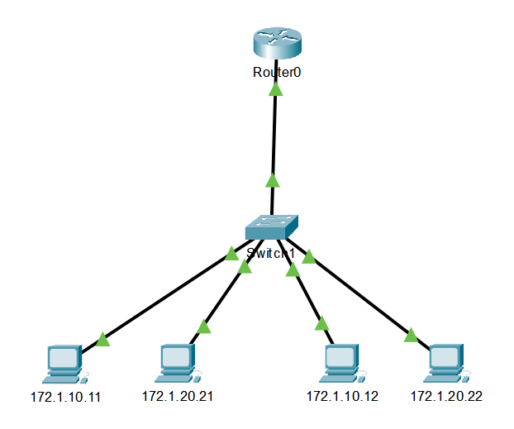

**Part 2: Additional Switch and PC**

Add a second switch and a fifth PC (PC13). Connect switches using ports G0/2. Don’t forget to configure new ports as either trunk or access based on the usage. At this point all PC’s should be able to ping each other!

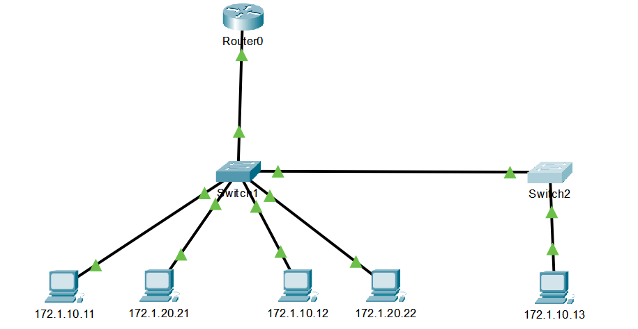

**Part 3: Additional PC’s and a Third VLAN**

Add two more PC’s (PC2 and PC3) connected as below. Connect PC 2 to port 2, PC3 to port 3.

Do all required switch and router configurations. When complete, all PC’s should be able to ping each other.

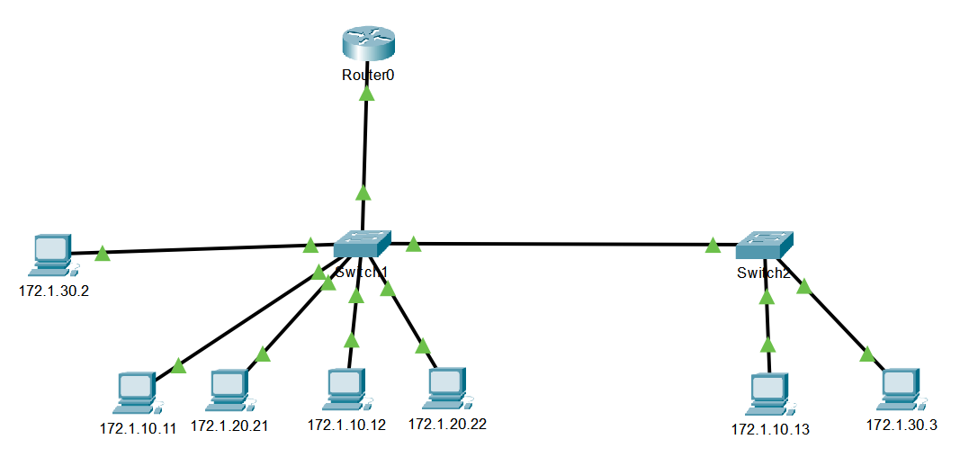

**Lab Completion**

1. Open a textbox with your name, id and “LAB 11B”
2. Open a textbox and include all new commands introduced in the second section of module 11.
3. Save your packet file as Lab11b-Lastname and submit via iLearn.